## Continuous delivery

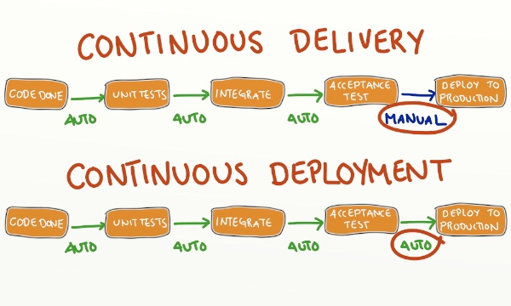

### Tools

* Revision control system: Subversion SVN
* Build server **Jenkins** : <http://jenkins.odesys.fr:9090/>
* Build engine **MSBuild (**<https://msdn.microsoft.com/en-us/library/0k6kkbsd.aspx>**). (***This tool is compatible with both Jenkins & TeamCity. It means no much changes expected if we want to switch Jenkins to Team City in near future.)*
* Unit test**: NUnit (**<http://www.nunit.org/>**)**
* Acceptance test **SpecFlow (**<http://www.specflow.org/getting-started/>**)**
* Coverage tool for .NET **OpenCover (**<https://github.com/OpenCover/opencover>**)**
* Package manager **Nuget (**[https://www.nuget.org**/**](https://www.nuget.org/)**)**

### Plugin Jenkins

* **MSBuild**

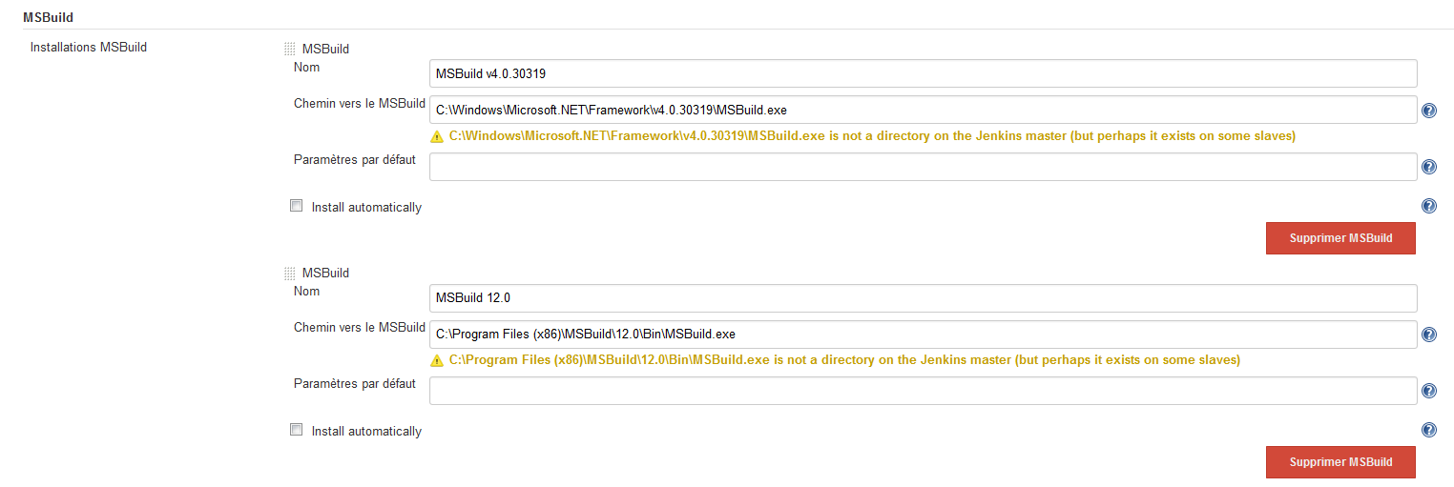

* **HTML Publisher plugin** (publish report coverage or customized report in HTML format)



### Organization Jenkins Job

For each project/solution, we need at least three types of jobs:

* $ProjectName_Continuous
  + Job will be executed after every commit into SVN

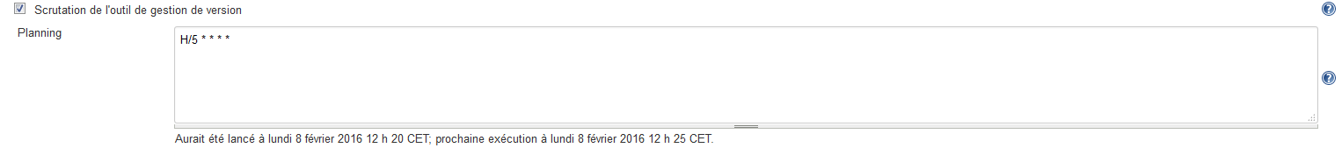

* + This kind of job will:
    - Compile solution
    - Execute unit/ acceptance tests
    - Report in failure case
* $ProjectName_Nightly
  + Job will be programmed at midnight
  + This kind of job will:
    - Compile solution
    - Execute unit/acceptance tests
    - Code analysis (Open Cover)
* $ProjectName_Deploy_$Environement
  + Job will be executed manually
  + This kind of job will :
    - Compile
    - Execute unit/acceptance tests
    - Create packages
    - Publish packages into repository/ deployment servers

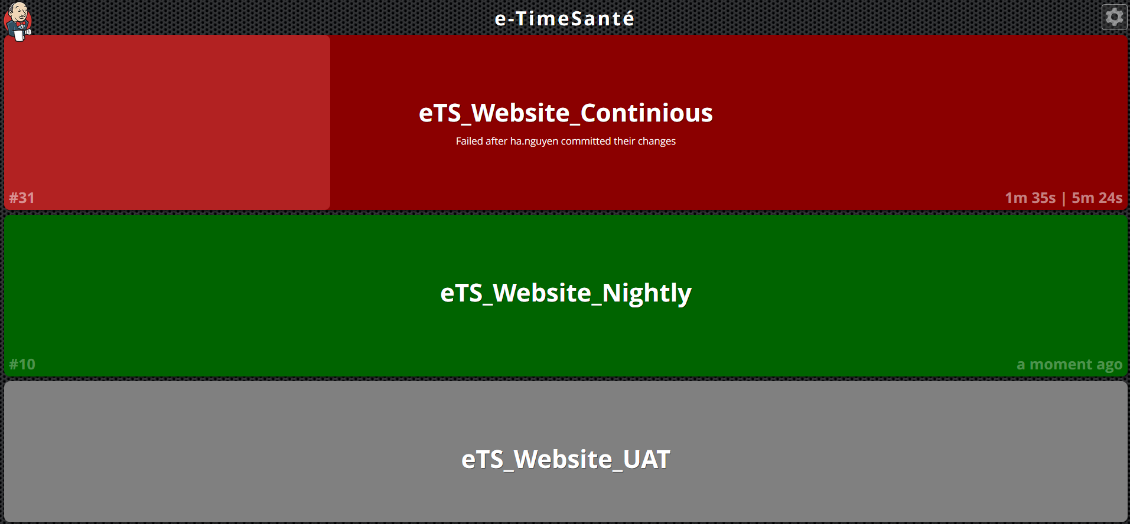

## Test automation

## Tools

* + NCrunch (<http://www.ncrunch.net/>) 🡺 TDD with NUnit
  + Test Generator NUnit Exetension Visual Studio (<https://visualstudiogallery.msdn.microsoft.com/bd30bf3f-4183-4b00-a245-1875316b8cd3>)
  + Refactoring tools: Resharper (<https://www.jetbrains.com/resharper/>)

## Example project

***Project : e-TimeSanté – CRA Website***

#### Step 1: Prepare necessary tools

* Prepare these tools in the subfolder **Tools.**

Tools :

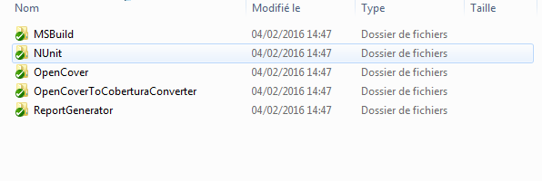

***Notes: We need these tools in solution folder in order to make it check out clean (compile everywhere)***

#### Step 2: Prepare MSBuild file

* Create a .msbuild with the same solution name.
* For example:



* In .***msbuild***, we will prepare necessary steps for MS Build command

Variables:

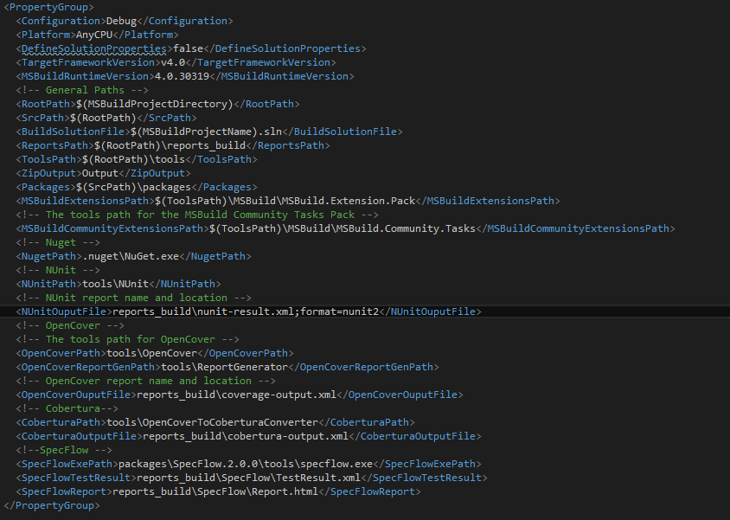

* Nuget restore packages:

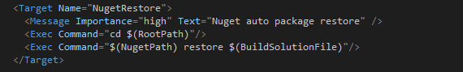

* Clean report/temporary folder

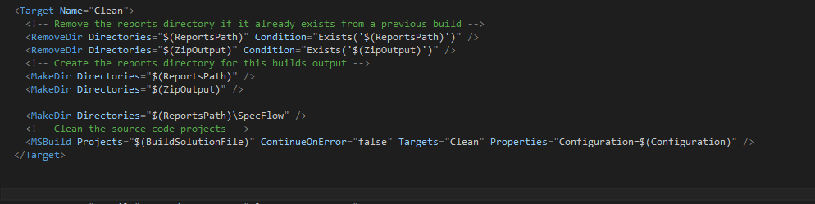

* Compile solution:

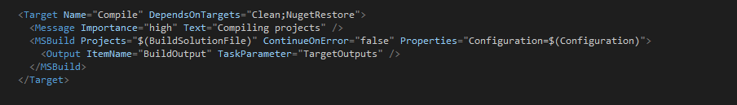

* Execute Unit tests:

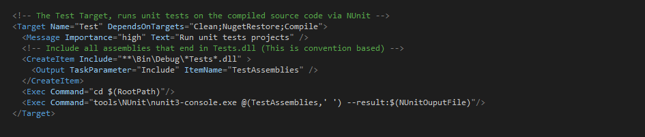

* Execute Acceptance tests (Not exist in this solution)

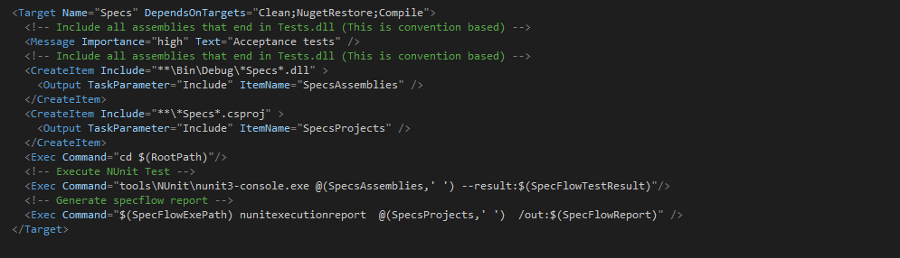

* Code coverage

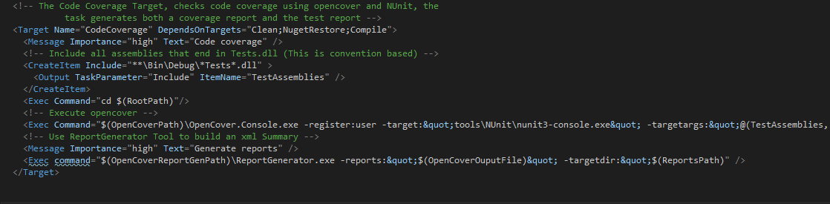

* Create Zip file (= Package for Website project which is not compatible with MS Deploy)

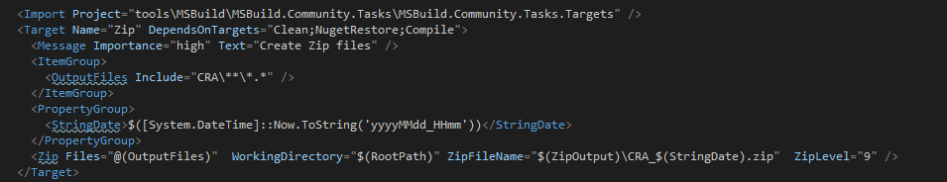

* Publish package into repository or deployment servers.

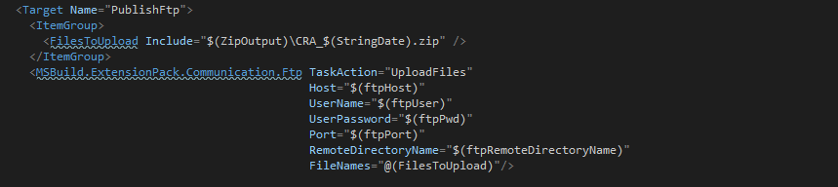

* Create complexes steps:



#### Step 3: Configure Jenkins Jobs

/p:Configuration=Release /p:Platform="Any CPU" /t:**Packages**

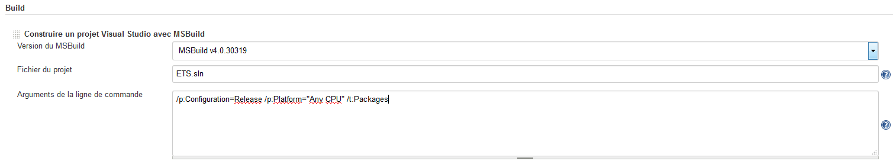

## Recommendations

* SVN
* XL deploy